1

PROFILE

1.1 PROJECT PROFILE
Project Title | fASHION MATRIX
Developed By | PRIYANSHI PANARA&PRINSI CHHATROLA
Developed For | Shree UPET Mahila College,Dhrol

Guided By
Duration | 3 Months
Front End Tool | PHP
Back End Tool | MYSQL
Editor | VS CODE
Documentation Tool | Microsoft Office Word 2007
Submitted To | Saurashtra University,Rajkot

1.2 COLLEGE PROFILE
College Name | Shree UPET Mahila College - Dhrol
College Address | Shree UPET Mahila college - Dhrol,  Jamnagar Rajkot Highway,  Taluko:Dhrol,  District:Jamnagar,
College Email | upet34003@gmail.com
College Website | www.umiyajicollege.org

College Phone Number
Affiliated with | Saurashtra University - Rajkot

2
PROJECT
PLANNING

2.1 INFORMATION GATHERING

We Gathered Information For Our Project From Following Ways :

- Definition
- Introduction
- Overview
- features
- scope
- Internet
- Questions

- Definition
Online shopping applications are digital platforms that allow consumers to purchase products and services directly from sellers over the internet using web browsers or mobile applications.

These applications aim to provide a convenient and time-saving shopping experience for users, enabling them to browse and buy products from the comfort of their own homes.

- Introduction
Online shopping is a form of electronic commerce which allows consumers to directly buy goods or services from a seller over the Internet using a web browser.
Consumers find a product of interest by visiting the website of the retailer directly or by searching among alternative vendors using a shopping search engine, which displays the same product's availability and pricing at different e-retailers.
- Overview
Online stores usually enable shoppers to use "search" features to find specific models, brands or items. Online customers must have access to the Internet and a valid Method of payment in order to complete a transaction, such as a credit card, an Interac-enabled debit card, or a service such as PayPal. For physical products (e.g. clothes), the e-tailer ships the products to the customer; for digital products, such as digital audio files of songs or software, the e-tailer usually sends the file to the customer over the Internet.

- Features

- User-friendly
- Mobile-friendly
- Payment options
- Customer service
- Reviews
- User features
- Product information

- Scope

• The current system can be extended to allow the users to create accounts and save products in to wish list.
• The users could subscribe for price alerts which would enable them to receive messages when price for products fall below a particular level.
• The current system is confined only to the shopping cart process. It can be extended to have a easy to use check out process.
• Users can have multiple shipping and billing information saved. During checkout they can use the drag and drop feature to select shipping and billing information.

- Internet
https://www.youtube.com/watch?v=1FWbwS08JIQ&list=PLdQESuyLp1NVkeLEMZNtxzuHkMiUHweg4

https://www.youtube.com/watch?v=bblKi-uSBD8&list=PL97P2RbKWLQiNwj3y8occuSuFAavyU3OT&index=28

- Questions
1.How many times do you shop online in a month?
- More than thrice
2.which payment method do you prefer for online shopping?
- Cash
3.how likely are you to recommend this site to other online shoppers?
- Very likely
4.which products are available in your shop?
- Jeans
- Shirt
- t-shirt
- kepri
- jackets
- shorts
- saree
- kurti

  - SYSTEM ANALYSIS
- Existing system
- An online shopping system is a process in which people are being provided with the option of purchasing goods and services directly from the seller, all in a real-time environment.
NAME | DESCIPTION | FEATURES
Audio experience | Lately many well-established apps are integrating audio experiences as enhancement to their apps. | the feature to create in-app podcasts for users available on various packages.
Buy-now-pay-later | Consumers increasingly expect a buy-now-pay-later (BNPL) feature service just like Afterpay as an alternate purchase option. | This feature allows users to make a purchase and pay later in several installments.
Social media integration | Social media integration is the strongest and biggest eCommerce feature in the retail tech world. | This is another great mobile ecommerce feature where users can also share various discount codes or promotional campaigns on their social media.
- Online shopping is an application of the internet as electronic commerce.

- Proposed system

- To remove all the disadvantages of conventional methods, a system is proposed which is an online shopping.

- The purpose of online shopping is to save time, save money.

- Through online shopping one can save his valuable time.

- One can watch and select things he wants to buy.

- Through online shopping we can save our money because prices are less than market prices and we receive our bought things at our home.

- No need to go anywhere and do shopping.

- We can get different varieties of things online and we can choose which one we wan

- Convenience
- Selection
- Immediacy
- Quality
- Saving money
- Discounts and offers

  - REQUIREMENT ANALYSIS

- Admin Requirement
- User Requirement

Admin Requirement:-
- User Management
- User Account:- Admin should manage user account,including viewing user profiles,deactivating account, and handling user issues.
2.Oreder Management:-
- Oreder Processing:- Admin need tools to view, process,and manage customer orders, including changing statuses and issuing refunds.
3.Product Management:-
- Add/Edit/Delete Product:- Admin should be able to add,edit and remove products from the cataog.
4.Content Management:-
- Website Content:-Admin should manage website content , including banners. Promotions, and static pages.
5.Security and Compliance:-
Data Protection:- Ensure user data is securely stored and managed, complying with redulations.

User Requirements:-
- User Requirement:-
Login/sing-up:- User should be also to register and login using email or social media accounts.

- Product Browsing and search:-
Product Categories:- User should be able to browse products by categories Le.g., men,women,kids.
3.Shopping cart and checkout:-
Cart Management:-User should add, remove, and update item in their shopping cart.
4.payment processing:-
Payment method:- support various payment methods like case on delivary.
5.Customer support:-
Support channels:- provide support through chat,email or phone.
6.Notification and alerts:-
Order updates:- user should receive notification about order status changes.

  - MODULE DESCRIPTION

      - Admin
      - User
- Admin
  - Admin cans personal login,name and password.
  - Admin can handle all data.
  - Like add,edit,delete,upate etc.
  - Admin can read feedback and delete feedback.

- User
  - User can only see the all information.
  - User can give the feedback.
  - User can personal login,name ane password.

3.
FEASIBILITY STUDY

3.1 TECHNICAL FEASIBILITY

3.1.1 Software Requirenment

Server Side Software Requirenment
Software Name |  | RAM |  | Hard Disk |  | Processing Power
 |  | Min. | Rec. | Min. | Rec. | Min. | Rec.
Operating System | Windows 7 | 1GB | 2GB | 16GB | 20GB | 1GHZ | 2GHZ
 | Windows 8 | 1GB | 2GB | 16GB | 20GB | 1GHZ | 2GHZ
 | Windows 10 | 1GB | 2GB | 16GB | 20GB | 1GHZ | 2GHZ
Editor | Dream  Weaver | 2GB | 4GB | 2GB | 4GB | 2GHZ | 2.6GHZ
Database Tool | MS SQL | 576 MB | 1GB | 4KB | 2GB | 2GHZ | 3GHZ
Web Server | XAMPP | 800MB | 1GB | 350  MB | 1GB | 3.2  GHZ | 5GHZ
Documentation Tool | MS Office Word 2007 | 256MB | 512MB | 1GB | 2.5GB | 500MHZ | 1GHZ
Browser | Google Chrome | 128MB | 140MB | 100  MB | 150MB | 1GHZ | 2GHZ
 | Mozilla Firefox | 512MB | 2GB | 200  MB | 250MB | 1GHZ | 2GHZ

Clients Side Software Requirenment

Software Name |  | RAM |  | Hard Disk |  | Processing Power
 |  | Min. | Rec. | Min. | . | Min. | Rec.
Operating System | Windows 7 | 1GB | 2GB | 16GB | 20GB | 1GHZ | 2GHZ
 | Windows 8 | 1GB | 2GB | 16GB | 20GB | 1GHZ | 2GHZ
 | Windows 10 | 1GB | 2GB | 16GB | 20GB | 1GHZ | 2GHZ
Editor | Dream Weaver | 2GB | 4GB | 2GB | 4GB | 2GHZ | 2.6GHZ
Web Server | XAMPP | 800MB | 1GB | 350 MB | 1GB | 3.2  GHZ | 5GHZ
Browser | Google Chrome | 128MB | 140MB | 100  MB | 150MB | 1GHZ | 2GHZ
 | Mozilla Firefox | 512MB | 2GB | 200MB | 250MB | 1GHZ | 2GHZ

3.1.2 Hardware Requirenment

Hardware Name | Company Name
Processor | Intel Core - 13
Motherboard | Intel
ATX – Cabinet | Intel
Keyboard | Dell 2 - 100
Mouse | Dell WM126
Monitor | Dell E2016HV
RAM | Transcend DDR - 3
Hard Disk | SATA

3.2 ECONOMICAL FEASIBILITY

3.2.1 Software Requirement

Software Name |  | Company Name | Price
Operating System | Windows 7 | Microsoft | 6000rs/-
 | Windows 8 | Microsoft | 8000rs/-
 | Windows 10 | Microsoft | 9000rs/-
Editor | Dream  Weaver | Adobe | 3000rs/-
Database Tool | MS SQL | Microsoft | Free Edition
Web Server | XAMPP | Microsoft | Open Source
Documentation Tool | MS Office 2007 | Microsoft | 2500rs/-
Browser | Google Chrome | Google | Open source
 | Mozilla Firefox | Mozilla | Open source

3.2.2 Hardware Requirement

Hardware Name | Company Name | Price
Processor | Intel Core - 13 | 8500rs/-
Motherboard | Intel | 4200rs/-
ATX – Cabinet | Intel | 120rs/-
Keyboard | Dell 2 - 100 | 600rs/-
Mouse | Dell WM126 | 450rs/-
Monitor | Dell E2016HV | 6500rs/-
RAM | Transcend DDR – 3 | 950rs/-
Hard Disk | SATA | 1900rs/-

4
DATA
DICTIONARY

4.1 NORMALIZATION

Un – Normalization

ID | T_Name | C_Name
1 | Tbl_Admin | Admin_id,Admin_name,username,password
2 | Tbl_Cart | Cart_id,cus_id
3 | Tbl_Cart  _details | Item_code,cart_id,price,size,quantity
4 | Tbl_Courier_Service | Courier_id,Courier_name
5 | Tbl_Customer | Cus_id,name,dob,username,password
6 | Tbl_item | Item_code,name,unit_price,type,category,item_desc,stock,image,admin_id,size
7 | Tbl_orders | Order_id,address,order_status,cus_id,courier_id,payment_id
8 | Tbl_orders  _details | Order_id,item_code,price,size,quantity
9 | Tbl_payment  _method | Payment_id,payment_method
10 | Tbl_review | Item_code,cus_id,review_id,review_disc

1st – Normalization
ID | T_Name | C_Name
1 | Tbl_admin | Admin_id
2 | Tbl_admin | Admin_name
3 | Tbl_admin | username
4 | Tbl_admin | password
5 | Tbl_cart | Cart_id
6 | Tbl_cart | Cus_id
7 | Tbl_cart_details | Item _code
8 | Tbl_cart_details | Cart_id
9 | Tbl_cart_details | Price
10 | Tbl_cart_details | Size
11 | Tbl_cart_details | quantity
12 | Tbl_courier_service | Courier_id
13 | Tbl_courier_service | Courier_name
14 | Tbl_customer | Cus_id
15 | Tbl_customer | Name
16 | Tbl_customer | Dob
17 | Tbl_customer | Username
18 | Tbl_customer | password
19 | Tbl_item | Item_code
20 | Tbl_item | Name
21 | Tbl_item | Unit_price
22 | Tbl_item | Type
23 | Tbl_item | Category
24 | Tbl_item | Item_desc
25 | Tbl_item | Stock
26 | Tbl_item | Image
27 | Tbl_item | Admin_id
28 | Tbl_item | size
29 | Tbl_orders | Order_id
30 | Tbl_orders | Address
31 | Tbl_orders | Order_status
32 | Tbl_orders | Cus_id
33 | Tbl_orders | Courier_id
34 | Tbl_orders | Payment_id
35 | Tbl_orders_details | Order_id
36 | Tbl_orders_details | Item_code
37 | Tbl_orders_details | Price
38 | Tbl_orders_details | Size
39 | Tbl_orders_details | quantity
40 | Tbl_payment_method | Payment_id
41 | Tbl_payment_id | Payment_method
42 | Tbl_review | Item_code
43 | Tbl_review | Cus_id
44 | Tbl_review | Review_id
45 | Tbl_review | Review_disc

2nd-Normalization
Primary key

T_id | T_Name
1 | Tbl_admin
2 | Tbl_cart
3 | Tbl_cart_details
4 | Tbl_courier_service
5 | Tbl_customer
6 | Tbl_item
7 | Tbl_orders
8 | Tbl_orders_details
9 | Tbl_payment_method
10 | Tbl_review
Feld | Data type
T_id | Int
T_name | String

1st – Normalization
ID | T_ID | C_Name
1 | 1 | admin_id
2 | 1 | admin_name
3 | 1 | Username
4 | 1 | Password
5 | 2 | Cart_id
6 | 2 | Cus_id
7 | 3 | Item _code
8 | 3 | Cart_id
9 | 3 | Price
10 | 3 | Size
11 | 3 | Quantity
12 | 4 | Courier_id
13 | 4 | Courier_name
14 | 5 | Cus_id
15 | 5 | Name
16 | 5 | Dob
17 | 5 | Username
18 | 5 | Password
19 | 6 | Item_code
20 | 6 | Name
21 | 6 | Unit_price
22 | 6 | Type
23 | 6 | Category
24 | 6 | Item_desc
25 | 6 | Stock
26 | 6 | Image
27 | 6 | Admin_id
28 | 6 | Size
29 | 7 | Order_id
30 | 7 | Address
31 | 7 | Order_status
32 | 7 | Cus_id
33 | 7 | Courier_id
34 | 7 | Payment_id
35 | 8 | Order_id
36 | 8 | Item_code
37 | 8 | Price
38 | 8 | Size
39 | 8 | Quantity
40 | 9 | Payment_id
41 | 9 | Payment_method
42 | 10 | Item_code
43 | 10 | Cus_id
44 | 10 | Review_id
45 | 10 | Review_disc

4.2 ER-DIAGRAMS

Entity

Relationship

Attributes

Item_code
Order_status
Cus_id
Courier_id
Payment_id

image
type
Unit_price
Courier_namee
Item_code
Admin_id
Review_disc
Review_id

Cus_id
Item_code
Tbl_review
Payment_method
Payment_id

Tbl_payment_method
quantity
size
price
Order_id

Tbl-orders-details
address
Order_id

Tbl_order
size
name
stock
item
category
Admin_id
Item_code
Tbl_item
dob
name
password
username
Cus_id
Tbl_customer
Courier_id
Tbl_courier_service
Cart_id
quantity
size
prize
Cus_id
Cart_id
Password
username
Admin_name
Tbl__cart_detail
Tbl_Admin
Tbl_cart
Manage
Admin
Fashion Matrix

Item_code
Order_status
Cus_id
Courier_id
Payment_id

image
type
Unit_price
Courier_namee
Item_code
Admin_id
Review_disc
Review_id

Cus_id
Item_code
Tbl_review
Payment_method
Payment_id

Tbl_payment_method
quantity
size
price
Order_id

Tbl_oreder_details
address
Order_id

Tbl_order
size
name
stock
item
category
Admin_id
Item_code
Tbl_item
dob
name
password
username
Cus_id
Tbl_customer
Courier_id
Tbl_courier_service
Cart_id
quantity
size
prize
Cus_id
Cart_id
Password
username
Admin_name
Tbl__cart_detail
Tbl_Admin
Tbl_cart
view
clinent
Fashion Matrix

4.3 Table Layouts

- Cart
- Cart_details
- Courier_service
- Customer
- Item
- Orders
- Orders_details
- Admin
- Payment_method
- Review

1 admin
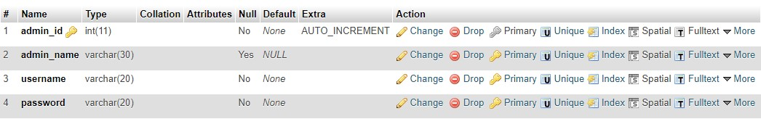

- cart

- cart_details
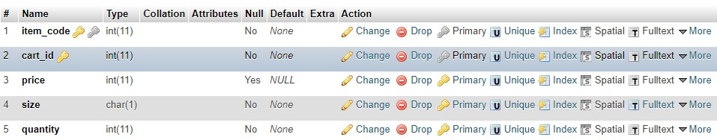

- courier_service

- customer
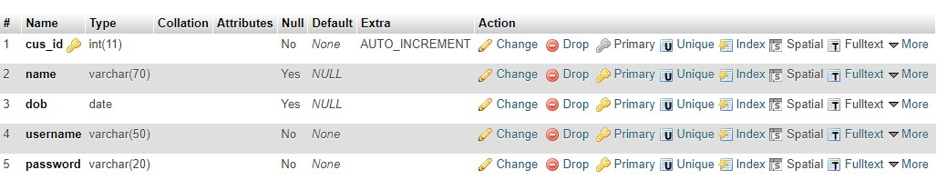
- item
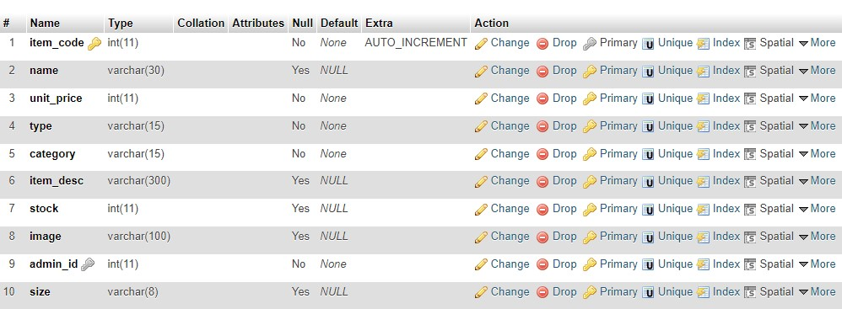

- orders
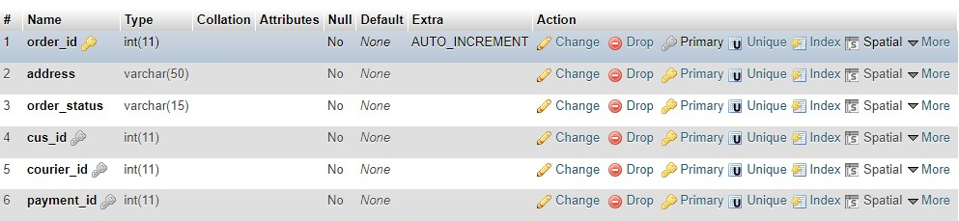
- orders_details


- payment_method

10 review
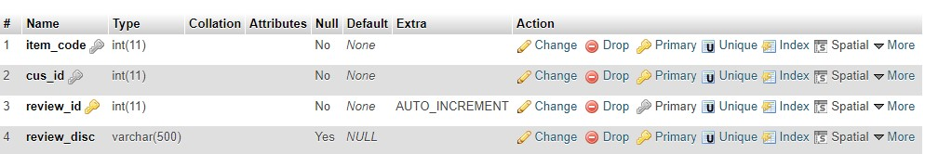

5.1 CONTEXT LEVEL DIAGRAM
Response

Response
Request
Request
Online fashion
ADMIN
USER
MySql
DataBase

5.2 DATA FLOW DIAGRAM

FIRST LEVEL DIAGRAM
ADMIN
Admin

cart

Cart_details

Courier_service

customer

Login
Admin

item

review
orders
Orders_details
Payment_method

client
cart

Cart_details
Courier_service

item

view
client

review
orders
Orders_details
Payment_method

- ADMIN :
admin

Add/Edit/Delete
admin

cart

Add/Edit/Delete

cart

Cart_detail

Add/Edit/Delete

Cart_detail

Courier_service
Courier_service
Courier_service

Add/Edit/Delete

Courier_service

customer
customer

Add/Edit/Delete

customer

ADMIN
LOGIN

item

Add/Edit/Delete

item

orders

Add/Edit/Delete

orders

Orders_details

Add/Edit/Delete

Orders_details

Payment_method

Add/Edit/Delete

Payment_method

review

Add/Edit/Delete

review

CLIENT :
cart
View
CLIENT

Cart_details

View

Courier_service

View

customer

View

View

item

orders

Add/View

View

Orders_detailss

Payment_methodd

Add/View

Add/View

Payment_methodd

login
Manage cart
admin
logout
View review
Manage payment_method
Manage orders
Manage orders_details
Manage item
Manage customer
Manage courier service

login
Manage cart
client
logout
manage review
Manage payment_method
Manage orders
view orders_details
View item
view customers
view courier service

5.4 screen layout
- Login page
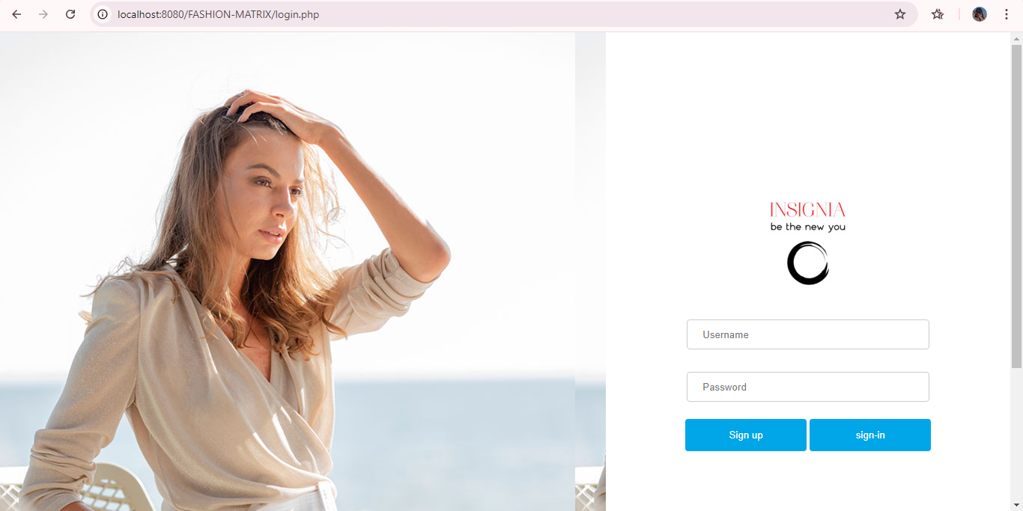

- Sign up page
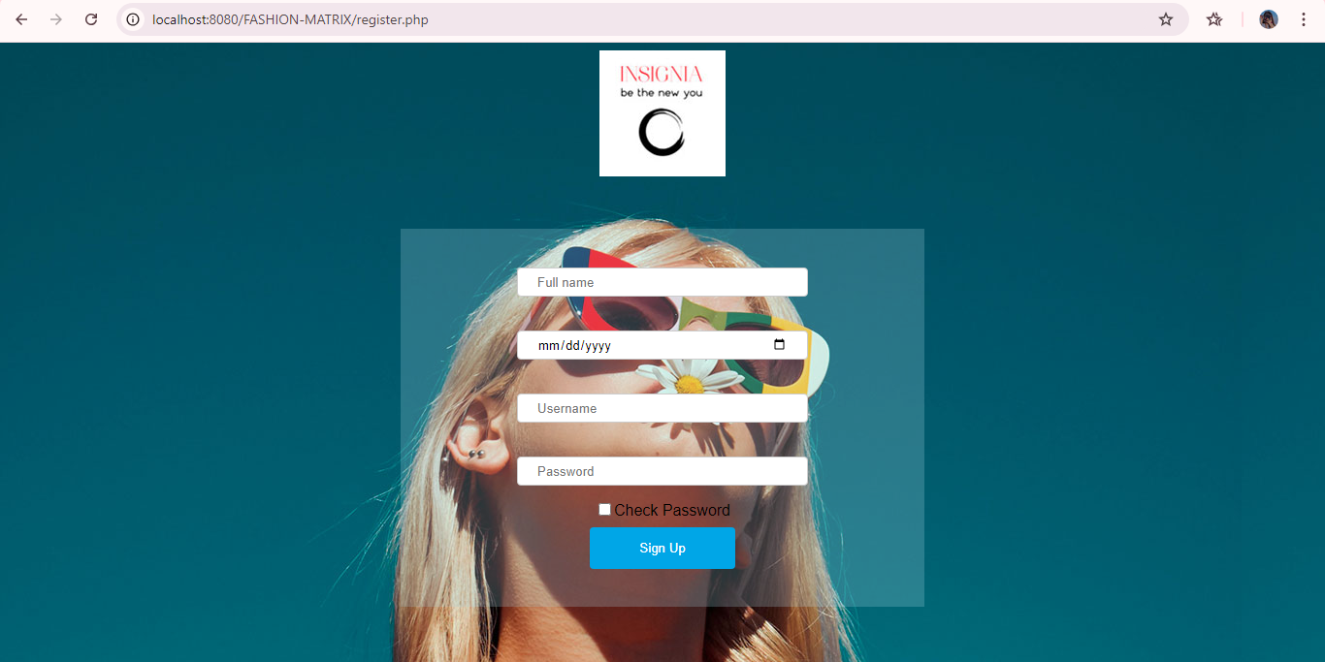
- Home page

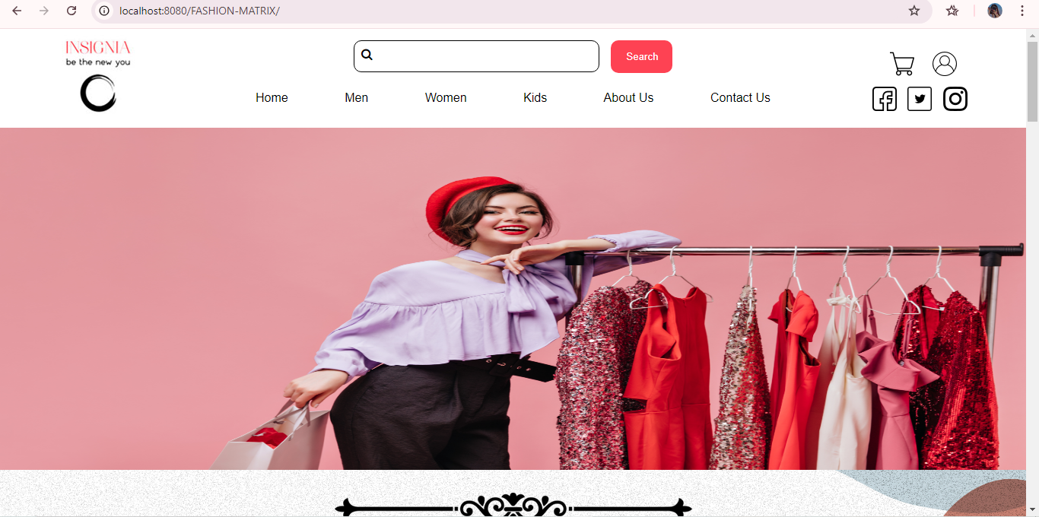

- Men page
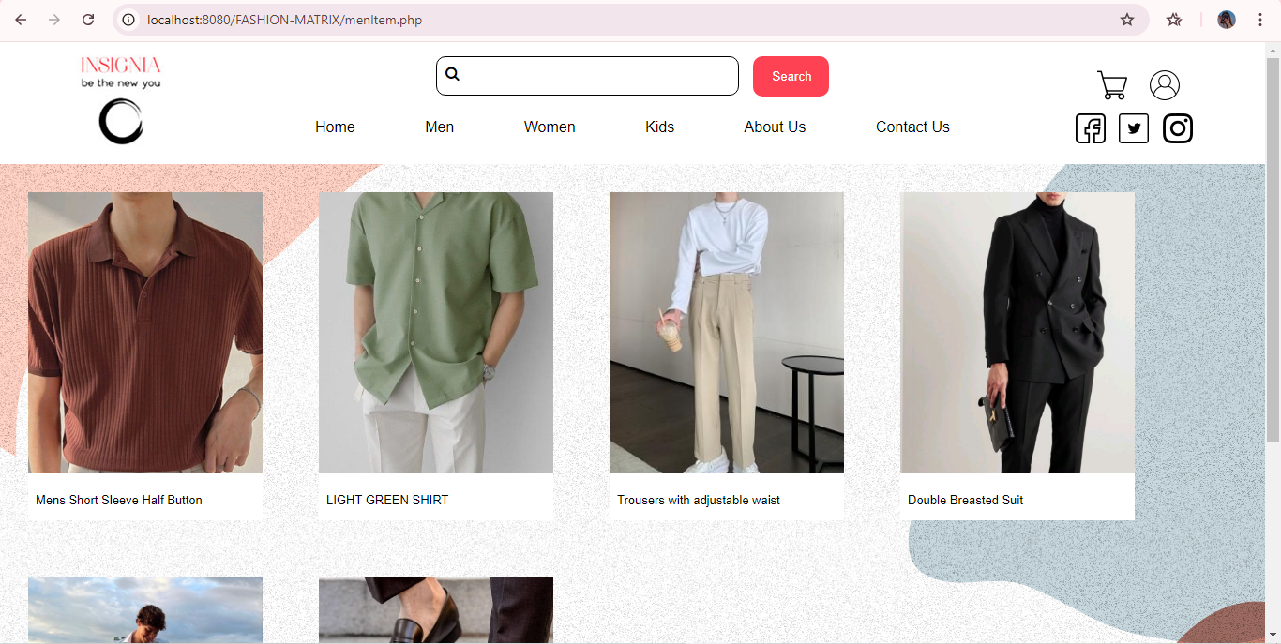
- Women page

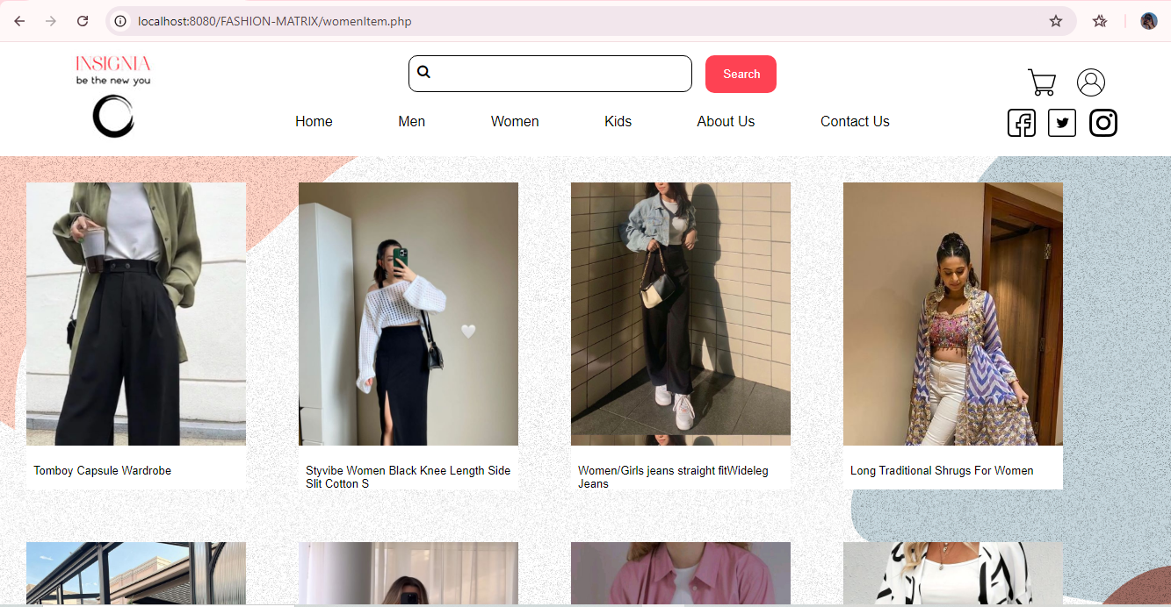

- Kids page

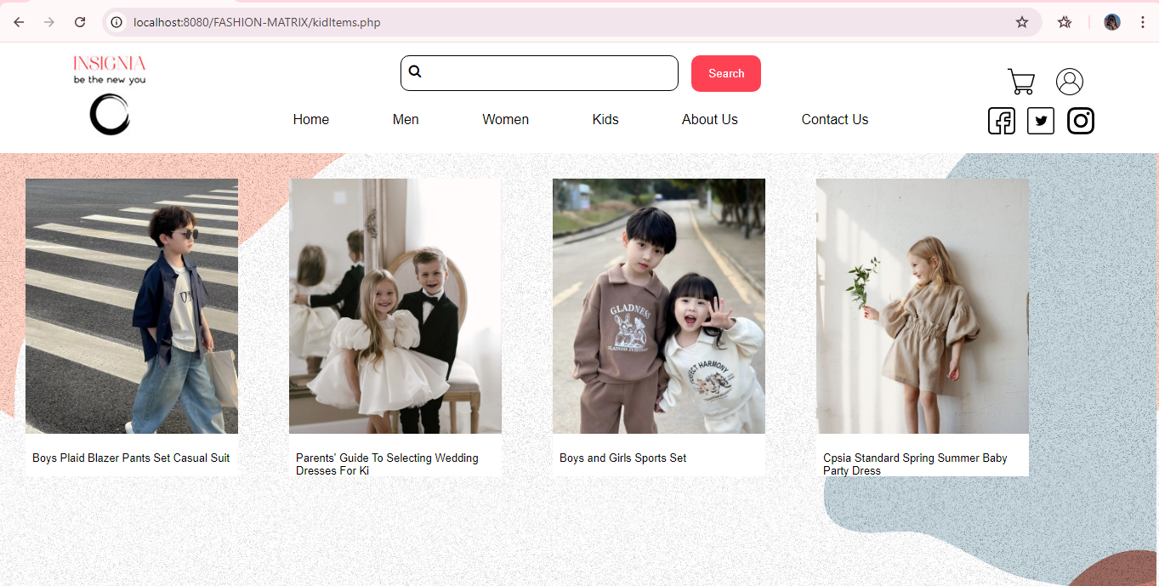
- About us

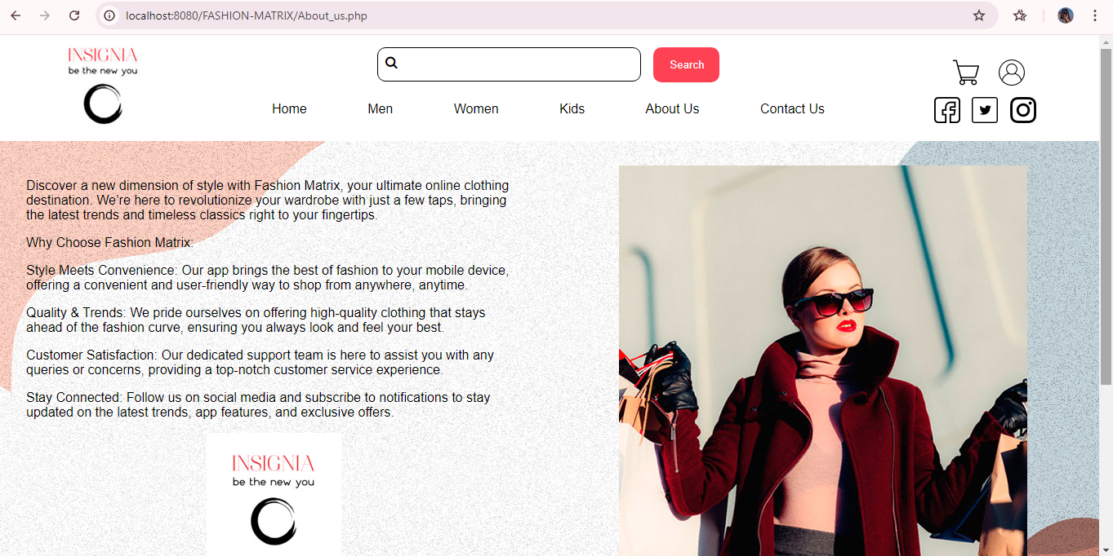

- Contact us

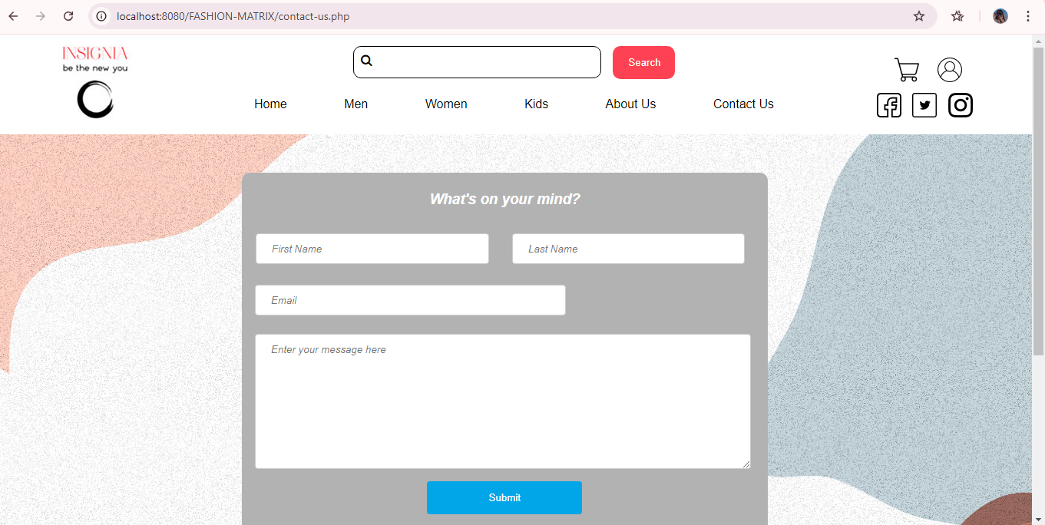

7
Testing

6.1 Black Box Testing
Black box testing treats the software as a “BLACK-BOX” Examining Functionality.
Without Any Knowledge Of Internet Implementation Without Seeing The Source Code.
The Testers are Only Aware Of What The Software Is Supposed To Do Not How It Does It.
Bellow Example Of Black-Box Testing .

LOGIN
TEST  ID | TEST  CASE | TEST  DATA | RESULT | ACTUAL  RESULT
1 | Enter valid data | Username=prinsi2005  Password=prinsi2505 | Successful  login | Successful  login
2 | Enter invalid  data | Username=  Password=prinsi2505 | Wrong username | Wrong username
3 | Check login with username | Username=  Password=prinsi2505 | Please Enter username | Please  Enter  username
4 | Check login with blank username password | Username=prinsi2005  Password= | Please  Enter  password | Please Enter password
5 | Check login with blank username&  Blank password | Username=  Password= | Please Enter username & password | Please Enter username & password
6 | Check login with invalid username | Username={..}…  Password=prinsi2505 | Please enter valid username | Please enter valid username
7 | Check login with invalid password | Username=prinsi2005  Password=123 | Please enter valid password | Please enter valid password
TEST  ID | TEST  CASE | TEST  DATA | RESULT | ACTUAL  RESULT
1 | Enter valid data | Name=prinsi  Username=prinsi2005  Password=prinsi2505 | Successful  login | Successful  login
2 | Enter invalid  data | Name=piyu  Username=piyu  Password=2505 | Wrong username  Name  password | Wrong username  Name  password
3 | Check login with username | Name=prinsi  Username=  Password=2505 | Please Enter username | Please  Enter  username
4 | Check login with blank username password  name | Username=  Password=  Name= | Please  Enter  Password  Username=  Password= | Please Enter password
5 | Check login with blank username&  Blank password | Username=  Password= | Please Enter username & password | Please Enter username & password
6 | Check login with invalid username | Username={..}…  Password=prinsi2505 | Please enter valid username | Please enter valid username
7 | Check login with invalid password | Username=prinsi2005  Password=123 | Please enter valid password | Please enter valid password

